# Title page

Pham Duc Thang,

ID: 001407356,

Course Title: Web Programming 2,

COMP1842

# Note: All we need in this logbook is screenshots. All code must be uploaded separately in a ZIP file.

# Weekly Tasks

## Logbook 3 - Week 3 tasks

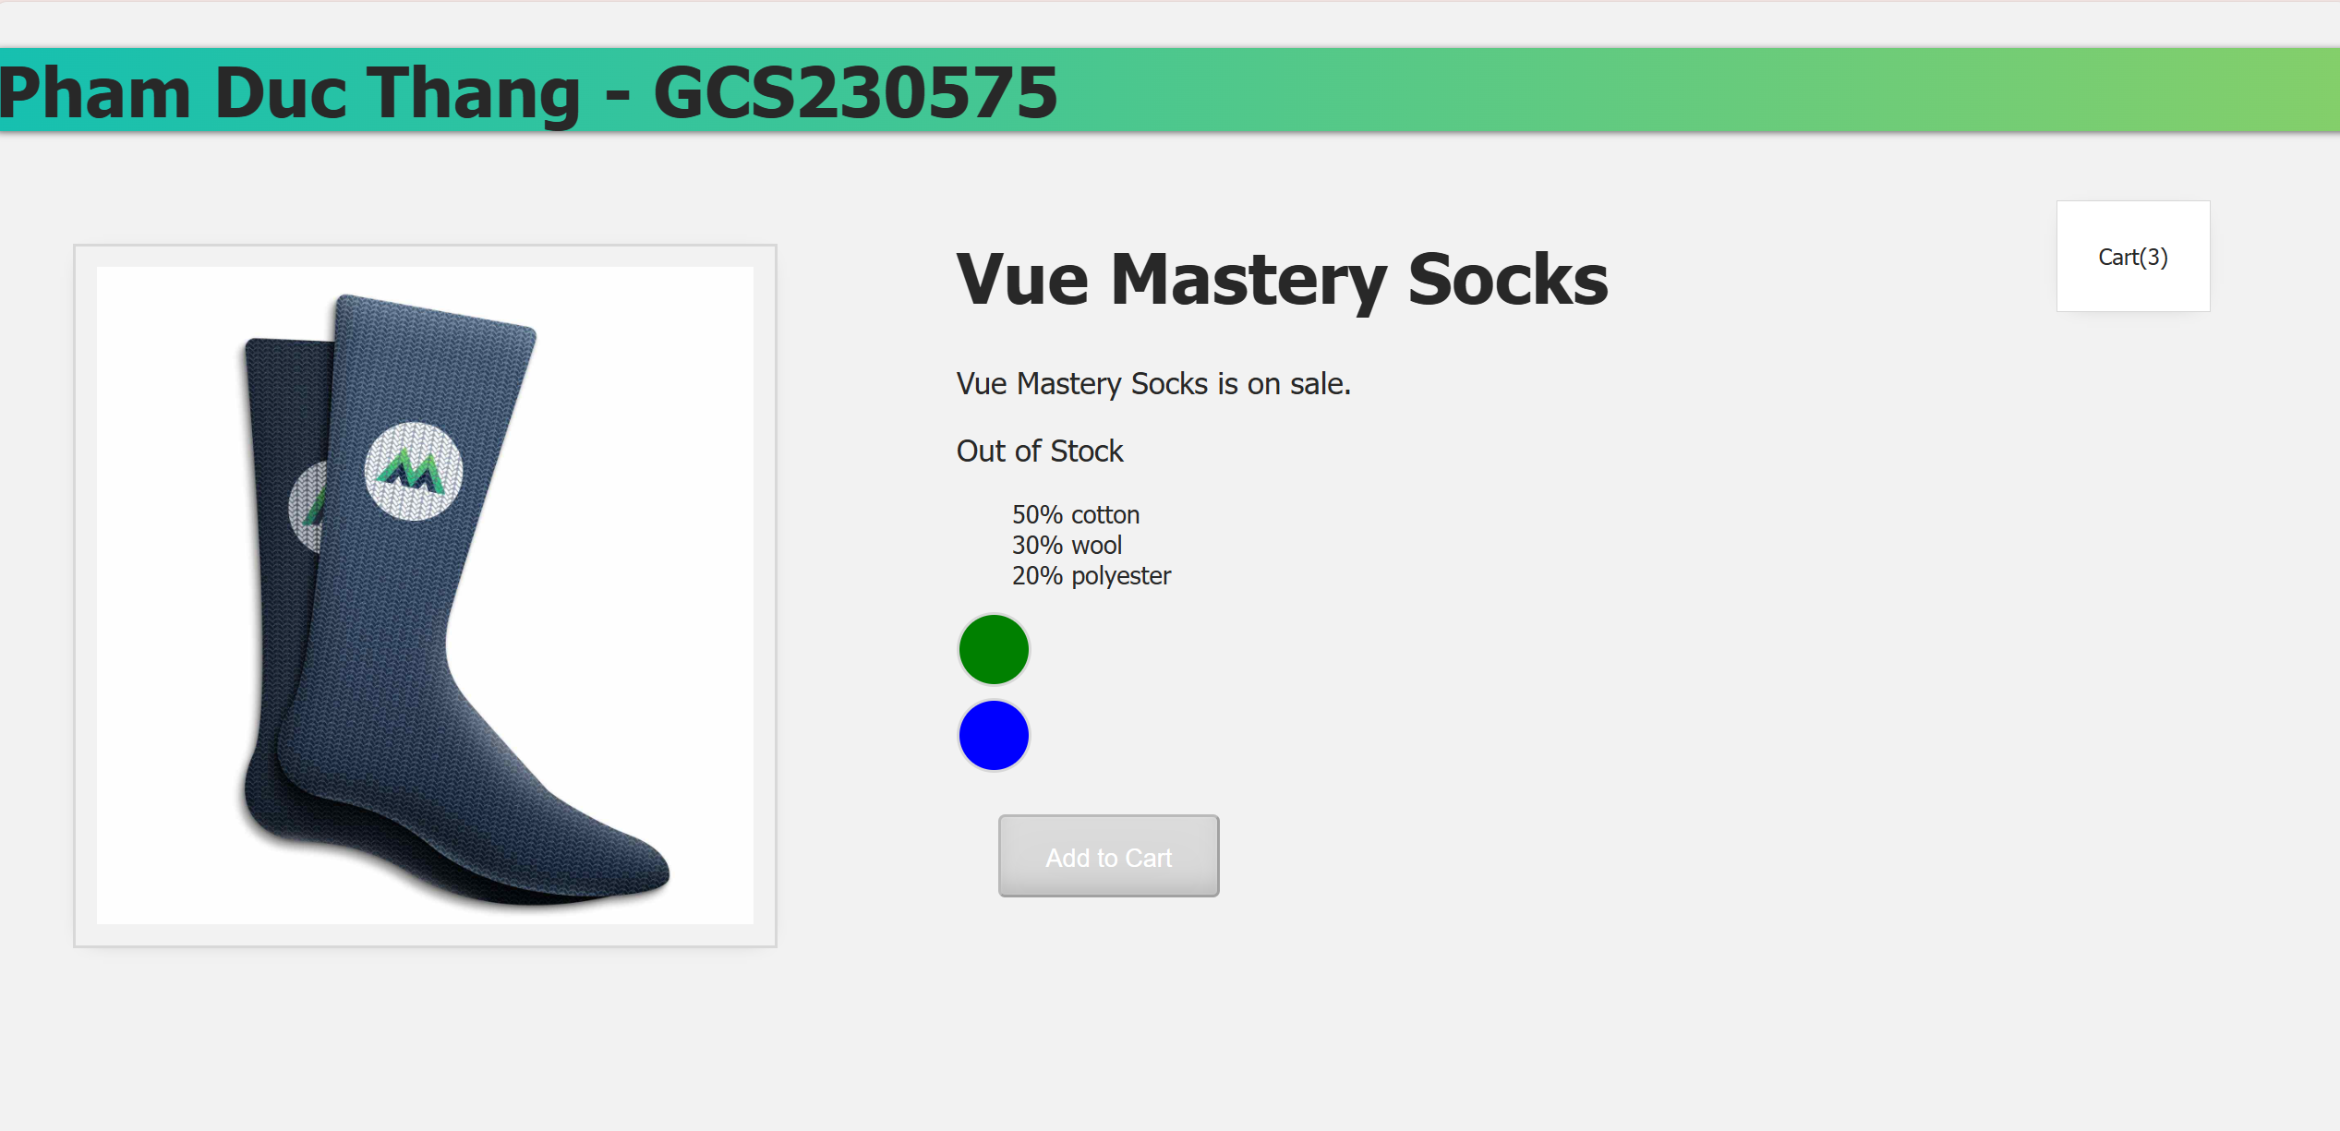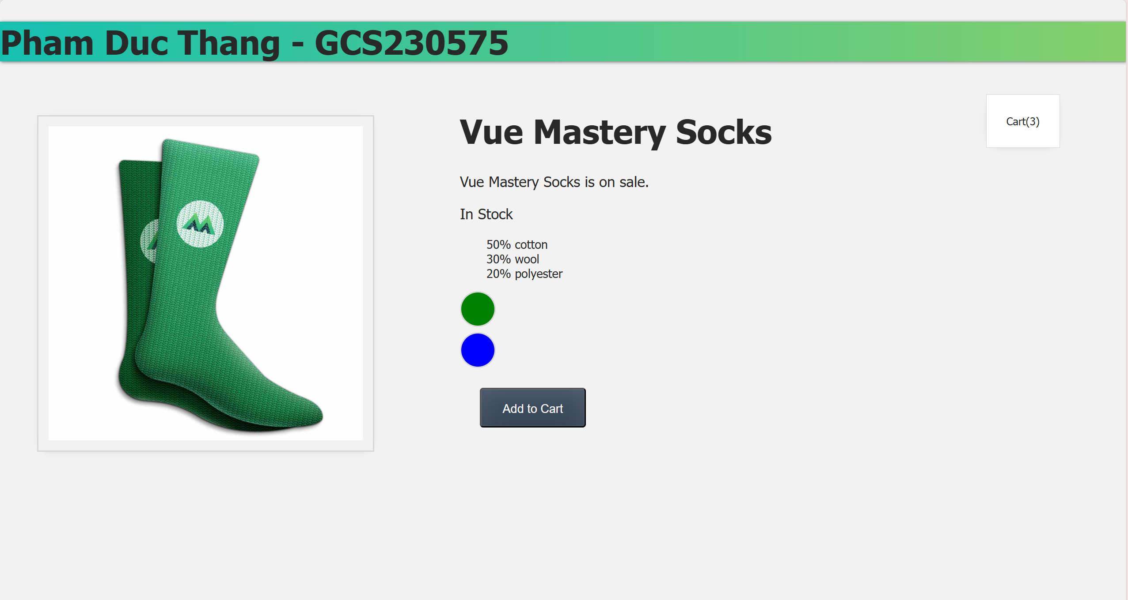

Lab 3 – week 3 – lesson 8. Computed Properties

Computed properties are attributes in Vue.js that are calculated based on reactive data. They allow to perform operations or process data without having to call a function each time, helping to keep the code clean and improve performance.

Unlike methods, computed properties are only recalculated when their dependent data changes, which helps optimize performance.

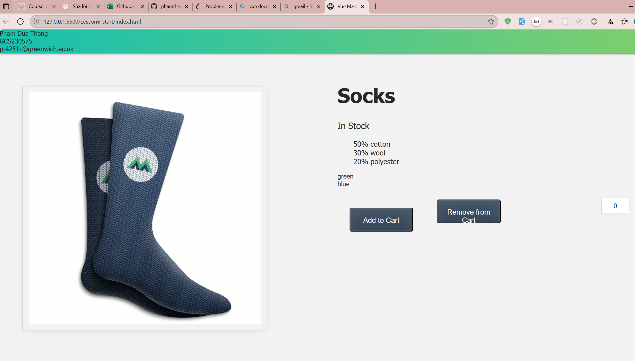

Lab 3 – week 3 – lesson 9 : Components and Props

• **Components:** Break complex UI into small, reusable parts to keep main.js clean.

• **Props:** Custom attributes to pass data from parent to child components; like React props, ...rest can be used to gather remaining props.

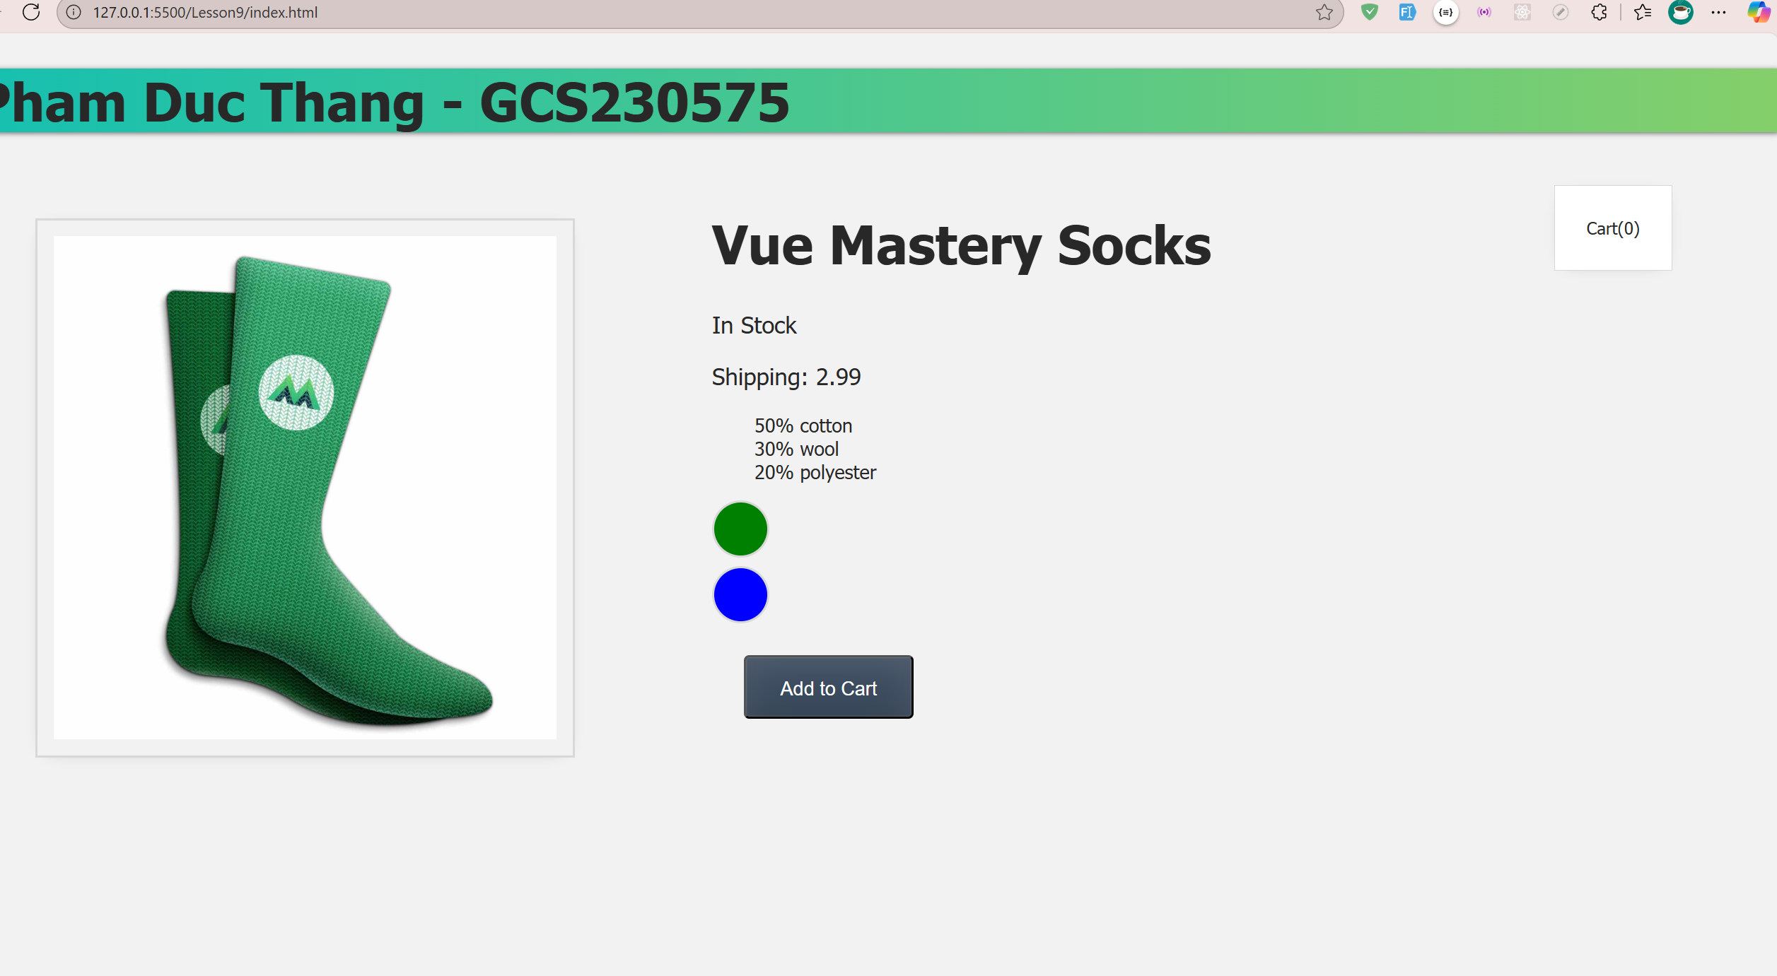

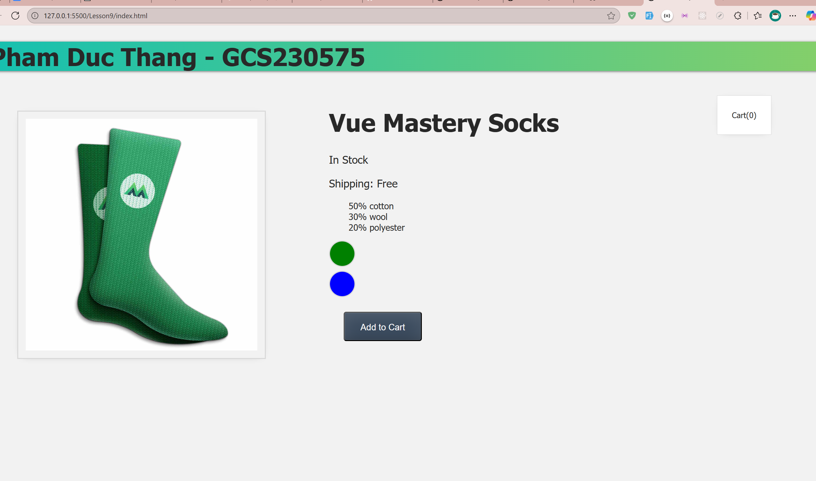

Lab 3 – week 3 – lesson 10: Communicating Events

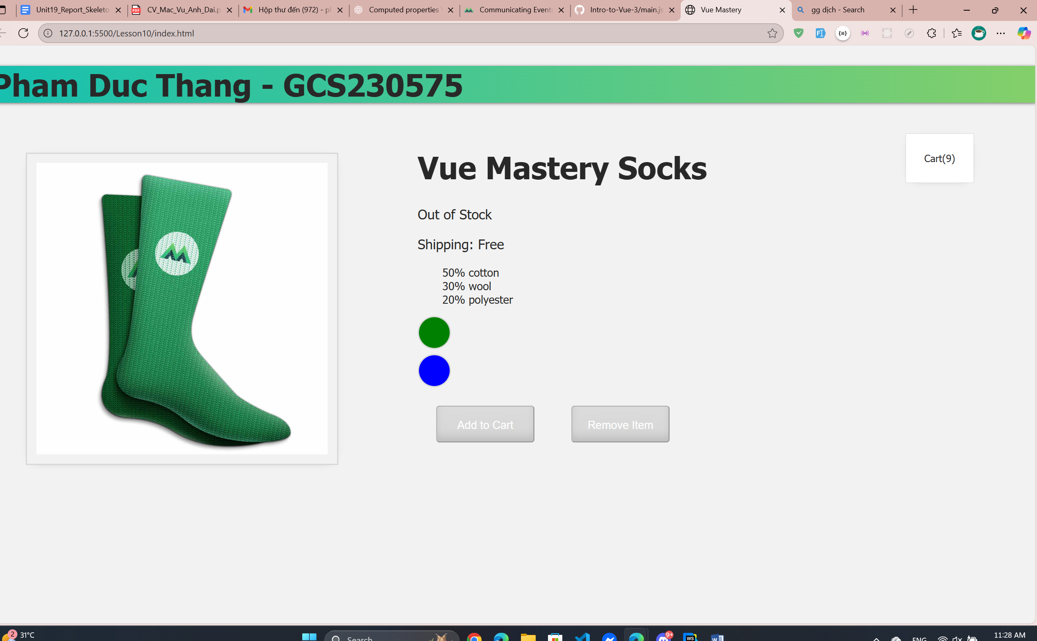

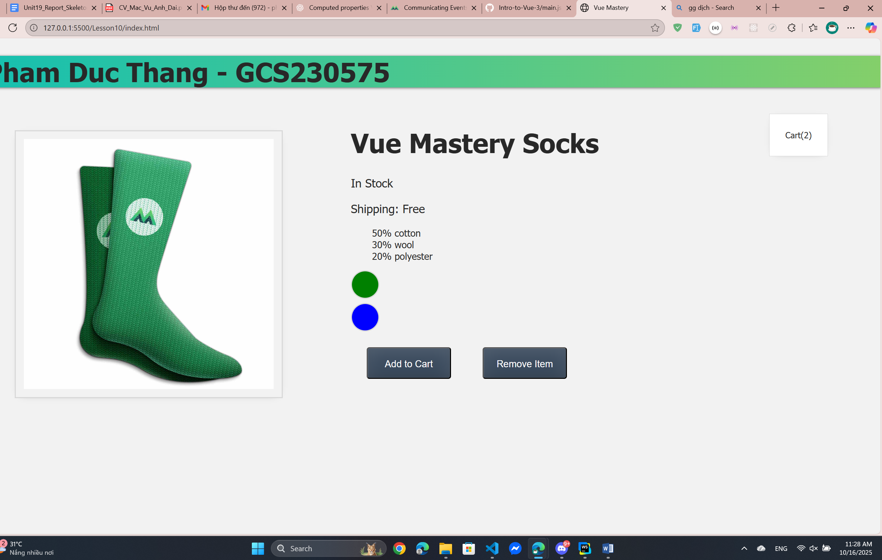

• **Problem:** Components have their own scope, so variables like cart in main.js cannot be accessed directly inside a component like ProductDisplay. The solution is using **events**.

• **Goal:** Understand how components communicate in Vue 3 using events.

• **Child → Parent:** Use this.$emit('event-name', data) to send events from child to parent.

• **Parent → Child:** Pass data via props.

Example:

Child component: this.$emit('update', newValue);

Parent component:

<ChildComponent @update="handleUpdate" />

methods: {

handleUpdate(newValue) {

this.value = newValue;

}

}

**Benefit:** Keeps components **reusable** and helps manage **state efficiently**.